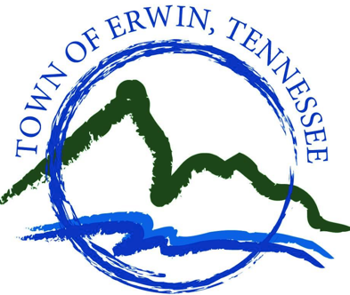
Welcome to the Town of Erwin’s new Service Request System from Dude Solutions!

Please view this Step by Step guide to better understand the process to Service Requests.

Step 1.
When you visit the erwintn.org, you can submit an online service request to Public Works by clicking on the
“Service Request” button located on the right-hand side of the Town of Erwin Homepage.

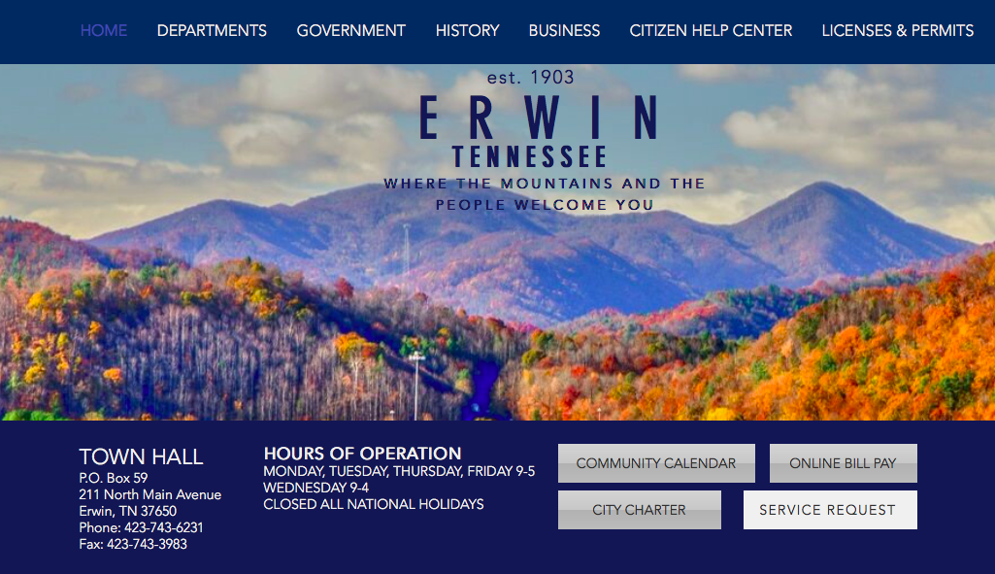

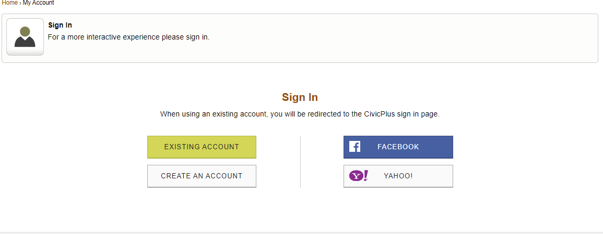
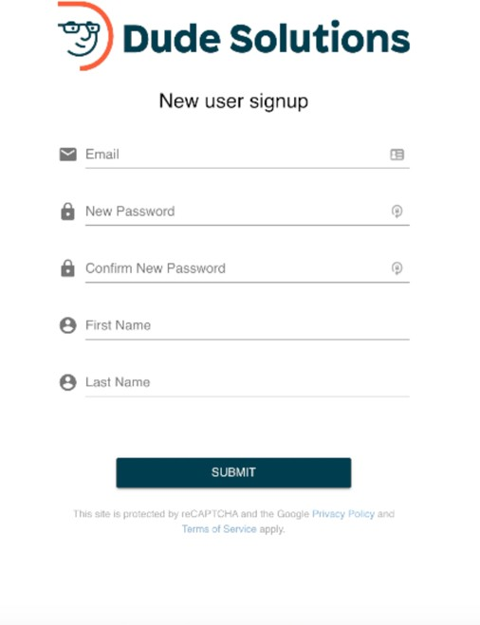
Step 2.

When you click on the “Service Request” icon you will be brought to the new Dude Solutions Citizen Request Portal. If you are visiting the portal for the first time you will need to create a login. Creating a login will allow you to track submitted work orders and receive notifications when your work order has been updated

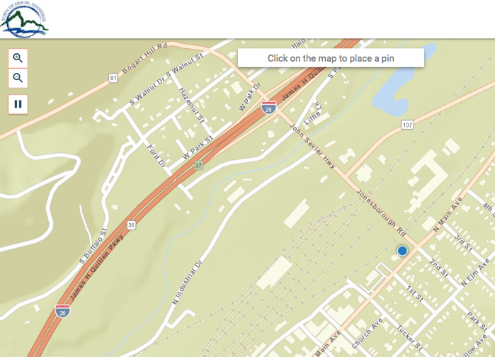
Step 3. Once you log in you will be brought to the new, simplified mapping interface. Clicking anywhere in the mapping interface will place a new pin on the map and create a new service request. For convenience, you be provided with a list of frequently submitted service request categories to select from. If you have a request that is not listed you can select either “Streets – Other” or “Safety Concern” and our staff will re-categorize the request as necessary.

Please Note: When you fill out your service request, please include as much detail as possible, such as: your name, address, phone number and any additional information that you feel the Town of Erwin may need. If you have a photo of the area you are submitting the request for, you can attach that to the service request as well.

IMPORTANT: If you have an emergency or need to report any other issue that requires immediate assistance, please call Town Hall during business hours at 423-743-6231, or call the non-emergency police number at 423-743-1850. Town Hall is not staffed on weekends and service requests may not always be processed immediately.

Step 4.
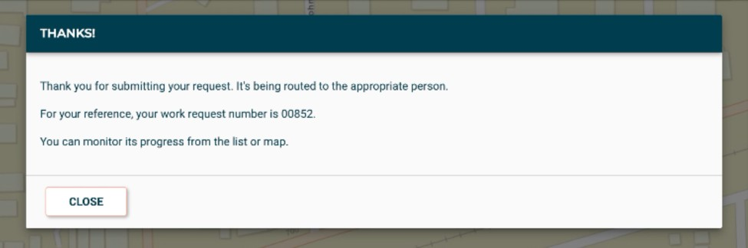
Once your request is submitted you will receive an email confirmation along with a request number. If you have submitted multiple requests, you can track those on the right- hand side of the screen when you are logged in.

The Town of Erwin appreciates your assistance in keeping our community safe and well maintained. Thank you for doing your part by submitting a service request.

If you need additional assistance in creating a Service Request or have questions regarding Service Requests, please feel free to contact us at 423-743-6231.

